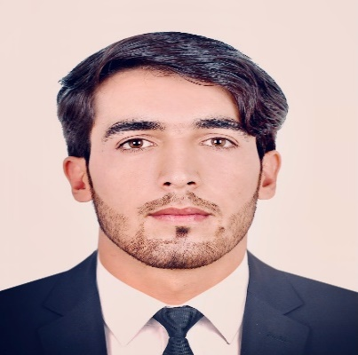
Mohibullah Rostamkhail
Education Attainment
Studied English language skill up to level nine (Advanced level) in ELCLC – ESO, Supported by US government at Kabul polytechnic university.

2015
Studied English language (Advanced level) up to senior one in Muslim institute.
2017
2021
would like to apply for job. This position sounds an excellent 0ppotunity for me to gain more experience and learn new skills. Documents such as Degree, Diploma, Work experience and certificates and reference letter will be provided on request for your convenience. Thank you for taking the time to review my application and resume and I welcome the discuss the position in the future detail at a personal interview.
Graduated from civil engineering of Alberoni university

Mohibullah.rostamkhil@gmail.com/ 0093780034426

Software knowledge
Graduated from Abdul Hadi Davi high school

Date of birth : 1997/05/05
English 
Pashto
Dari

Work Experience
- Had Worked as project manager at HERO HAIDER Construction Company for two years.
- Had taught Engineering programs in Afghan Association for two years in Kabul.
- Worked at Ministry of Agriculture as internship in on form for four months.
- Had taught English Language for one years in Raheb- e- Danishqah.
- Had taught English Language in Nawi Hakim Nasir khusrow Balki in Kabul.
- Had taught Math physics and science subjects at Usman Waris International high school for two years in Kabul.

Graduated from Alberoni university faculty of civil engineering
2016
INTERESTS:
- Mostly studying books and newspapers.
- Playing football and do swimming.
- Working with people.
- Eager to learn different culture

Auto cad, civil 3D
3DS MAX 2020
Office Automation 2007 – 2020
Certificates
- Completed Auto cad , civil 3D , SAP , SAFE , ETABS , in Aqeel construction
- Company
- Completed civil engineering programs at DARA foundation supported by France government.
- Completed Leadership and time management in ILD supported by government of Germany
- Completed talk and talk program at Muslim English language institute .
- Got certificate best teacher of the year from manager of Usman Waris International high school.
Graduated from ( DEL ) program of KARDAN university.
Primavera p6
SAFE, ETABS
2015

