Bashir Ahmad
Information Technology manager with more than 10 years of experience.
Direct of Teaching, whit more than 1 year of experience.
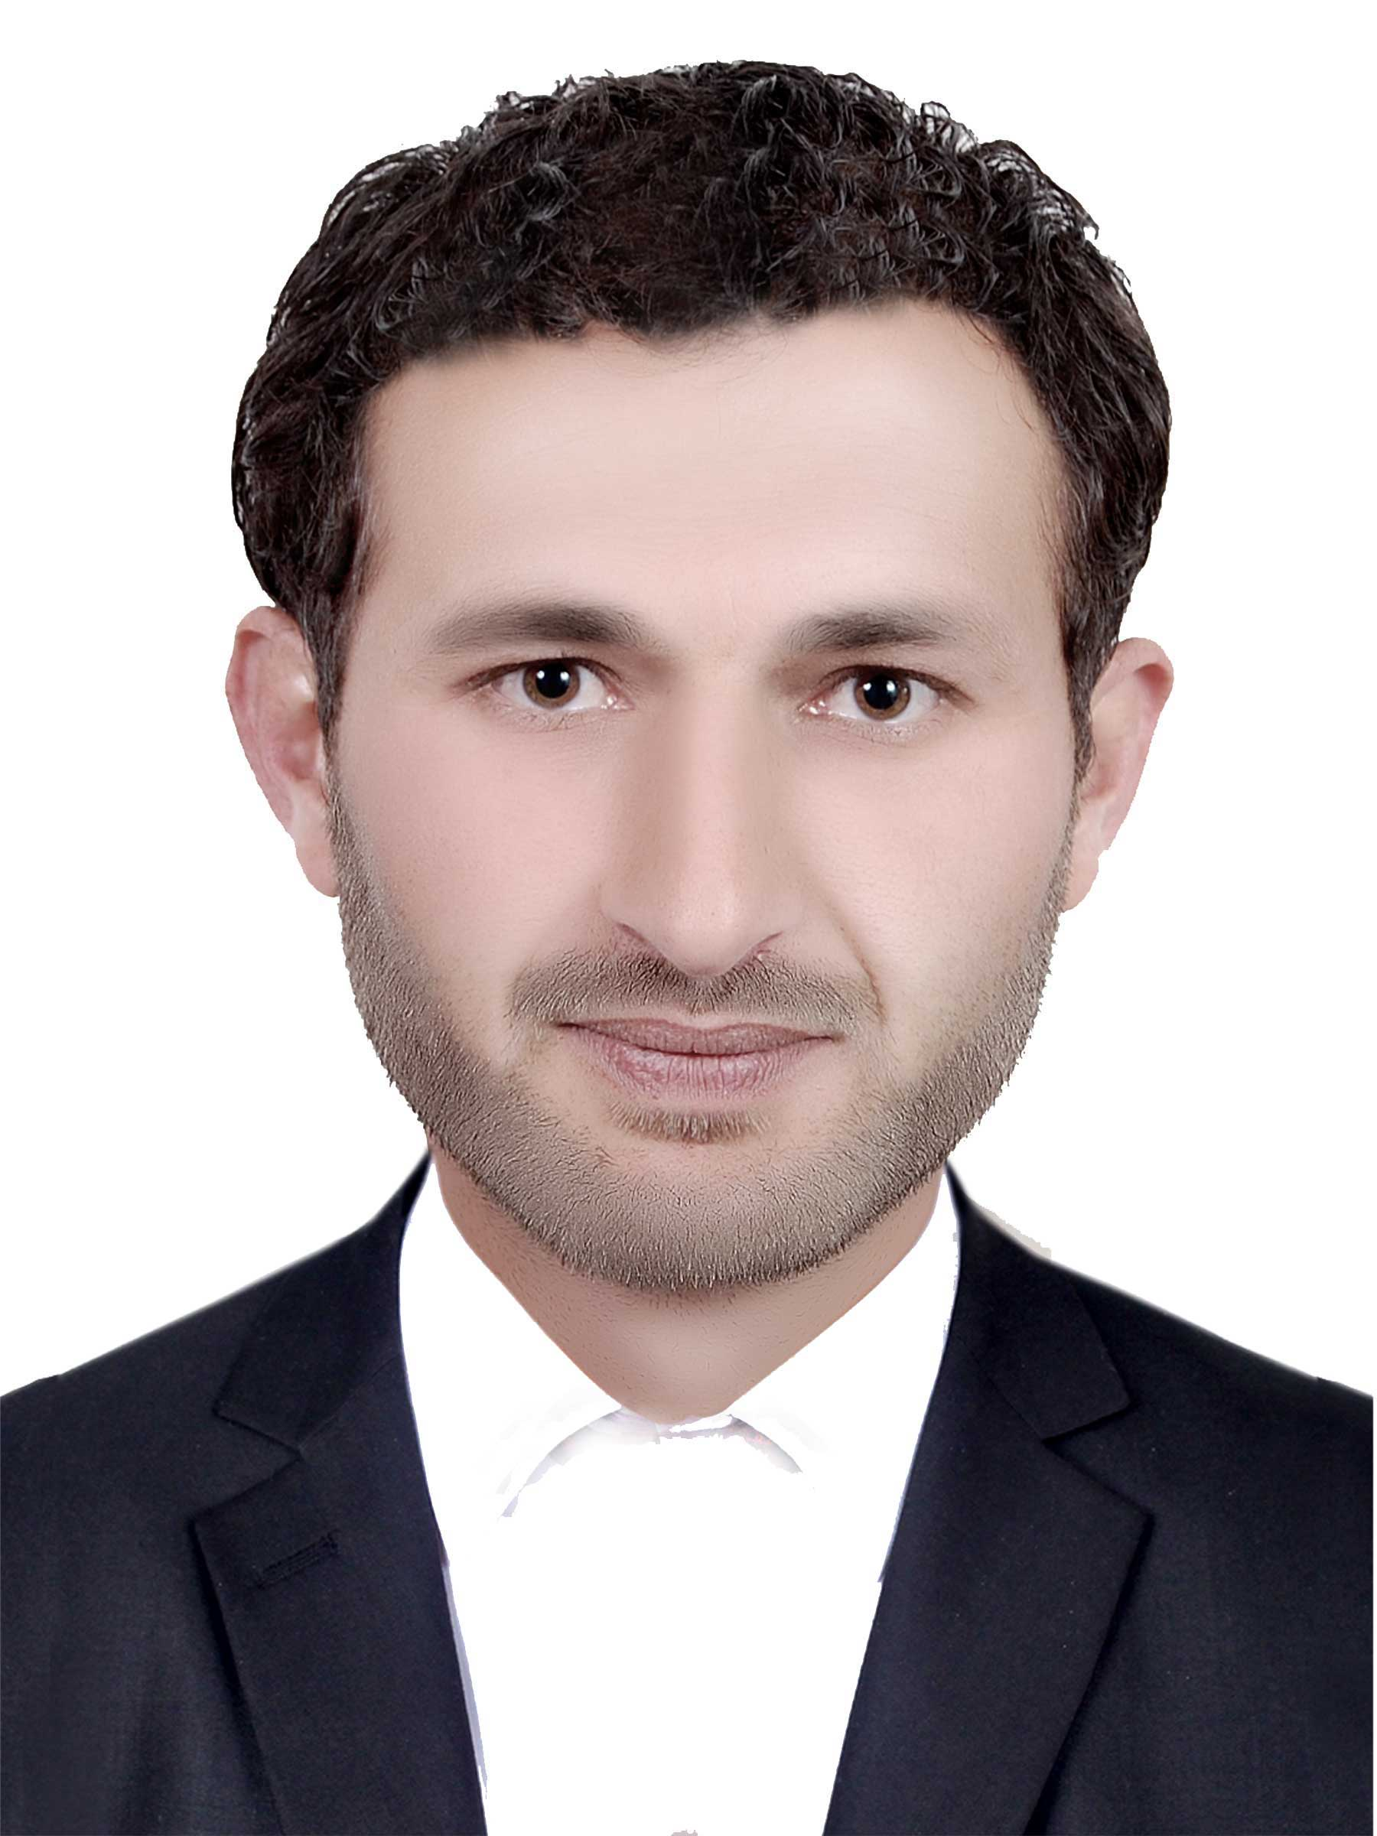
Professional experience
Information Technology Manager, Independent Election Commission, kapisa, Afghanistan
Personal information
Address
Afghanistan First Part Of Kapisa Province

Phone number
0093796137554

Email
Bashir.nadim.456@gmail.com

Skills
- Skill Highlights
- Project management
- Strong decision maker
- Complex problem solver
- Creative design
- Innovative
- Service-focused
LANGUAGES
- Persion
- Pashto
- English

11/11/2009 to 18/8/2020
- Lead a team of 4 representatives.
- Develop and implement
- Build strong relationships with existing.
Direct of Teaching, Technical And professional Education, Parwan , Afghanistan
10/21/2022- up to now
Department of leadership, control, supervision, organization, performance evaluation, provision of facilities and implementation of rules, regulations, and procedures above the relevant departments.
Education
Bachler of law and political, University Danish institute, parwan , Afghanistan
Year obtained: 2021

Degree in information Technology, IEC, Kabul, Afghanistan
Year of obtaining: 2009 up to 2020

Hobbies
- Playing chess - great way to unwind,
- destress, and keep the mind sharp.
Reference
Zabihullah Haqshenas
PH: (0093) 794050530
Address: Parwan Province Afghanistan

