Resume | Zabihullah  Present Address:  Phase # Sayyaf Family, Nangarhar, Afghanistan  Contact :0780782394/0767032688  Email:Zabihullahmaroof2@gmail.com
  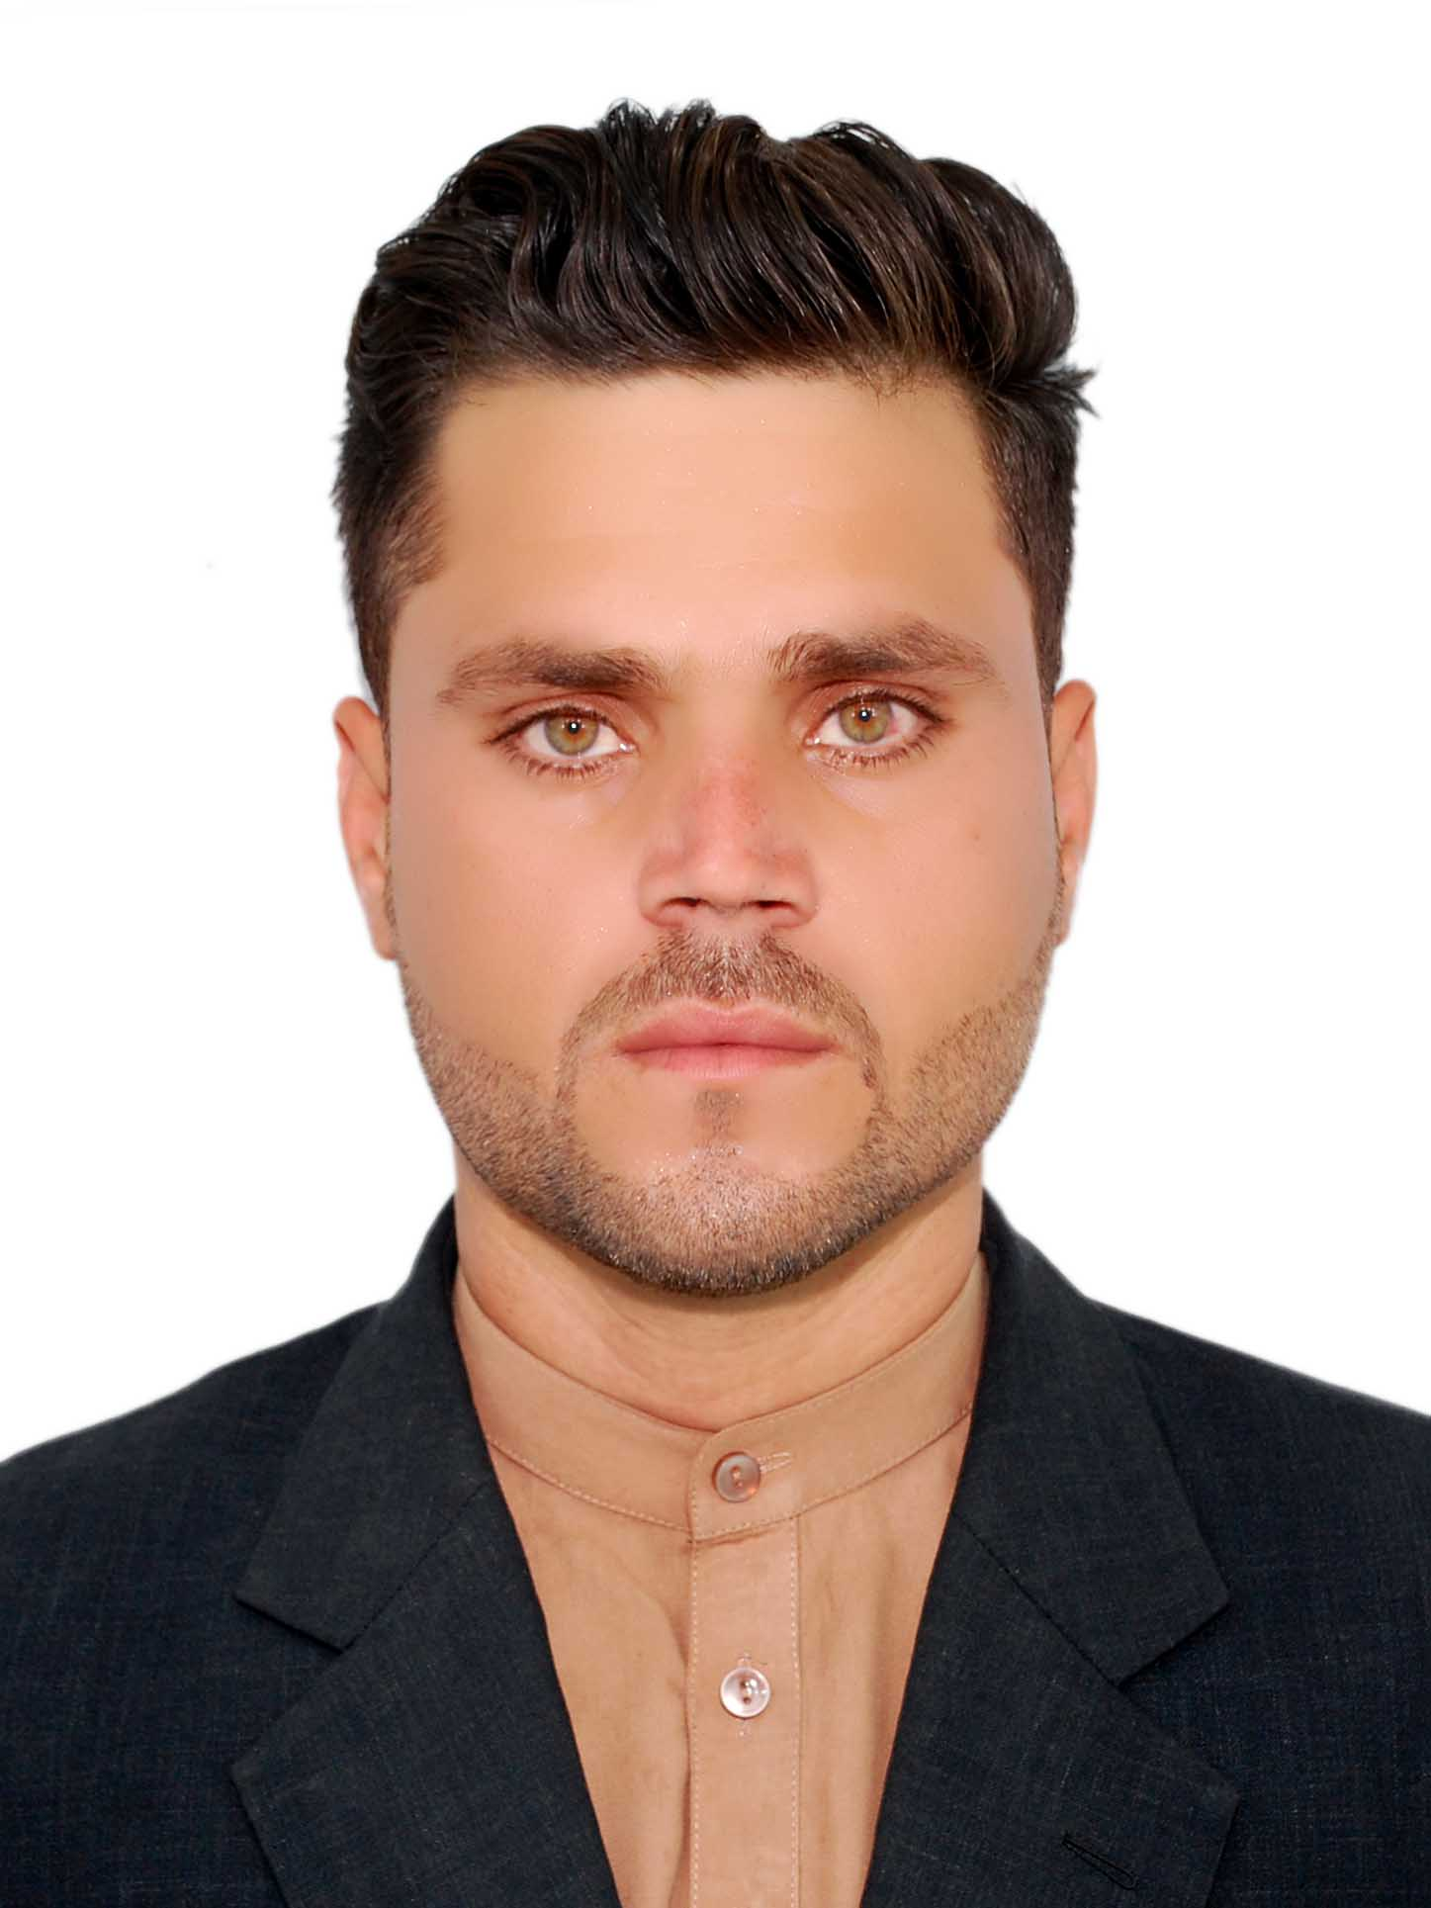
Father Name: Nasibullah
Date of Birth: 19/Mar /1995
Place of Birth: Peshawar, Pakistan
Six: Male
Nationality: Afghan
Marital Status: Single
Religion : Islam
Native language: Pashto

Objective:

To join a career oriented, motivated, and up growing with reputable organization to enhance skills
and serve humanity.
Education Background:
2002 – 2014 : High School (Mia Omer High School) Nangarhar.

2015 – 2017 : (ATVI) Afghanistan technical and vocational institute

2018 – 2022 : Bachelor in Civil engineering at (Nangarhar University) Nangarhar.
Other Courses Background:

- March 2018: Certificate In Survey(Engineering)

- Level Machine
- Total Station
- GPS

2. Feb 2015 : Certifacate of IRC( English Language )
2 .Sep 2017: Certificate of Completion of the Course requirements for the Following modules.
1. Basic 2.Internet 3.Windows 4. MS Word 5. MS Excel 6. MS PowerPoint
7. Basic Computer Hardware, Discussion posts, and Skype call conference calls.

Work Experience

Teacher at (Hamza Maroof High School )
(2, 04, 2018) To (19, 11,2019)

Worked as a site engineer in building a residential house
(22, 05, 2017). (9, 02, 2019))

Surveyor Assistant at(Construction company)
(4,01,2016). To. (03,02,2018)

Hobbies and Interests:

- Research and Studying
- Video games
- Playing Cricket

MS Windows.
MS Word.
MS Excel.
MS Power Point.
MS Access.
Internet.
Hardware.

Language Skills:

Languages | Speaking | Writing | Reading | Understanding
Pashto (Native) | Excellent | Excellent | Excellent | Excellent
Dari | Excellent | Excellent | Excellent | Excellent
English | Very Good | Very Good | Very Good | Very Good
Urdu | Very Good | Good | Good | Very Good

