
COVER LETTER
TO:
SUBJECT: Apply for
VACANCY NO:
DATE:
Dear MS/MR,

Through Some reliable sources I have recently found out your prestigious office recruits some new employers, I am confident that I will contribute toward the achievement of your organization goals and subject, you will find me a dedicated person who strongly believes in tin work achieving personal and professional excellence.

Consequently

I am looking forward to hearing soon for you and appreciate in advance any given chance for an interview. Attached please find copy up my C.V for your further consideration, I am available to talk at your convenience. I will be in touch next week to follow up and to make sure you have received my application.
Thank you so much for your time and consideration.
Sincerely,
Noor Rahman “MASOOD”

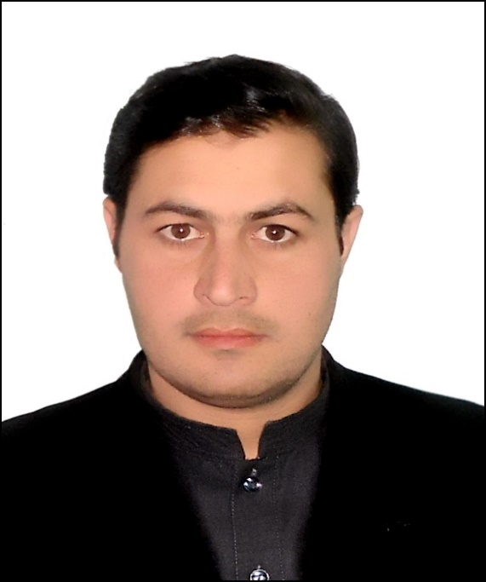 |  | noor rahman masood
PERSONAL INFORMATION  Sure Name: Noor Rahman “MASOOD”  Father's Name: M. zahir “MASOOD”  Date of Birth: August/13/1993  Place of Birth: Kabul-Afghanistan  Marital status: Married  Nationality: Afghan  ID Card NO: 1399-0900-27652  wORKSHOP/TRAINING  Business Skill Training and It is certificate  From USAID, Afghanistan Trade and Revenue Project.  “Youth and Trade” Training and It is Certificate from USAID, Afghanistan Trade and Revenue Project.  Hostile Environment Awareness Training and It is Certificate from USAID"ATAR" Afghanistan Trade and Revenue Project.  Training of Elementary education program of procurement from national procurement Authority-Afghanistan.  Training of Anti-corruption, Principles of Administrative Ethics and letter writing program from Administrative Reform-Afghanistan.  Training of Medium education program of procurement from national procurement Authority-Afghanistan.  Contact  Phone:  0774137628 - 0781194861  What’s App:  0774137628  Email:  noorrahmanmasood@gmail.com  REFERENCE  Reference will be given on Demand. |  | EDUCATION  Kandahar university (2011 – 2015)  Studied Economic Faculty, Department (M&BA) management & business administration.  Khushal Khan High School (2004 – 2010)  graduated from the sixth to the twelfth class in the first grade inside high qualification.  WORK EXPERIENCE  Ministry of Refugees & Repatriations-Manager of Consultancy Services Procurement  March/31/2018 – Until now  Manage, Supervision of the design, arrangement and approval of tender documents, bets, Previous eligibility assessment documents, Quotation request documents, Procurement announcements and etc.  Sadat Lajaward Company -Financial Manager  Oct/01/2016 – Nov/19/2021  Perform financial calculations and execution of administrative costs and Staff’ salaries.  USAID-ATAR Project International Chemonics-Economist Intern  May/07/2016 – Nov/06/2016  Participate in trade sector workshops, Survey on the problems of Afghan Investors and training in the administrative department of the Ministry of Trade and Industry of Afghanistan.  SKILLS  Computer Skills:  Studied MS Windows, MS Word, MS Excel, MS Excess, & MS PowerPoint, Photoshop, Internet, Hardware & Software Operating system all version, fast typing "Dari Pashto and English”.  Languages:  Work Ability  Able to work hard, active, smart, and creative, able to learn quickly and have affective communications and organization skills.
  Languages | Speaking | Understanding | Writing | Reading
  English | Excellent | Excellent | Excellent | Excellent
  Dari | Excellent | Excellent | Excellent | Excellent
  Pashto | Excellent | Excellent | Excellent | Excellent
Able to work as a leader of Team, Positive attitude and high level of initiation initiation, Patience and high tolerance regarding a flexible environment.

